37.22: a) In Eq.(39-24), 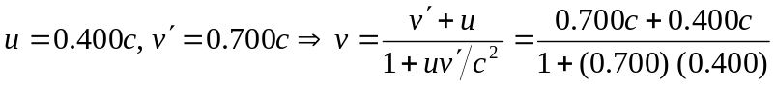
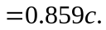
b) 